1. **Agenda**:
   1. We will implement method reference using consumer functional interface.
2. 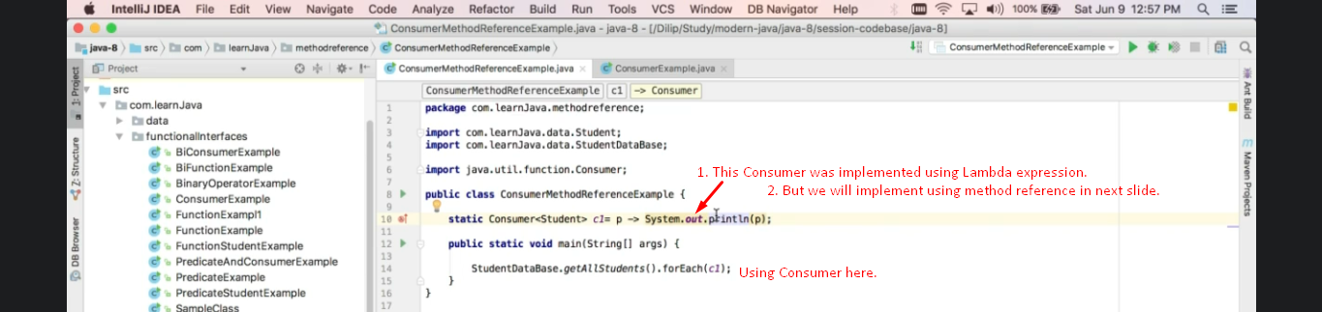
3. 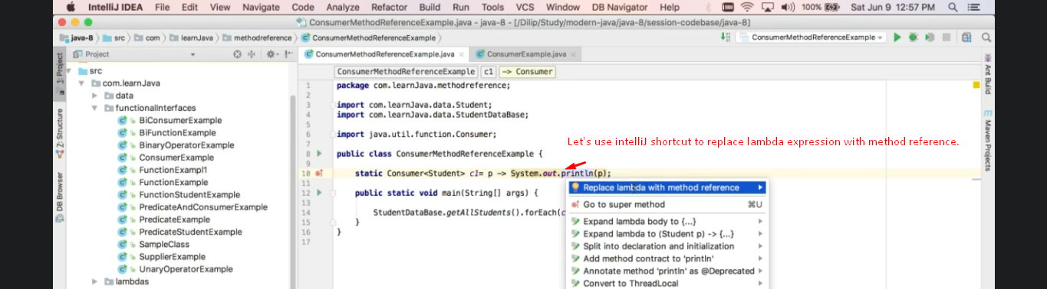
4. 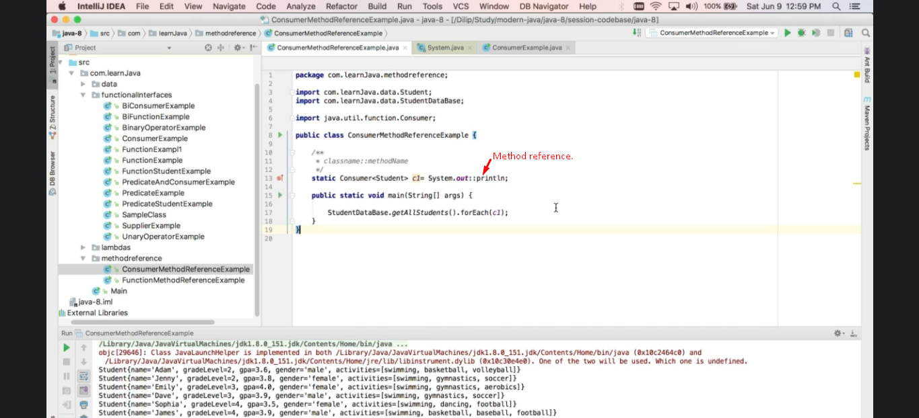
5. 